1. Declare global variables

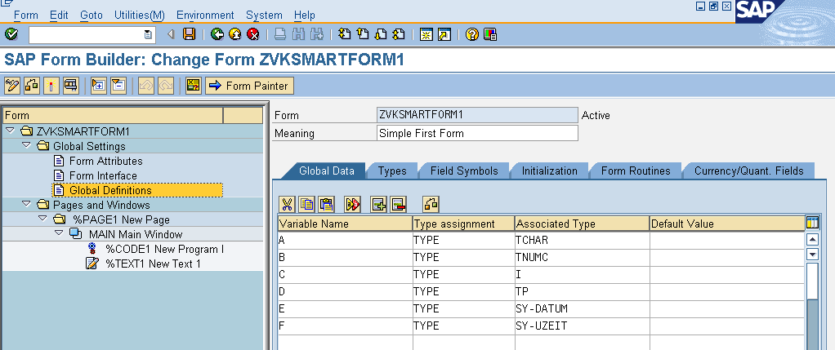
A TYPE TCHAR
B TYPE TNUMC
C TYPE I
D TYPE TP
E TYPE SY-DATUM
F TYPE SY-UZEIT

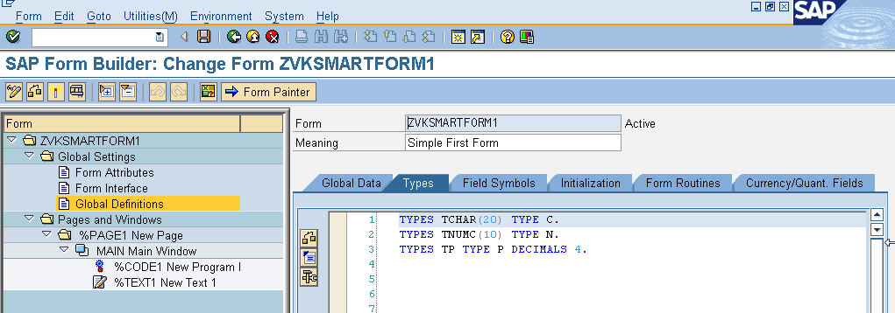 types tchar(20) type c.
types numc(10) type n.
types tp type p decimals 4.

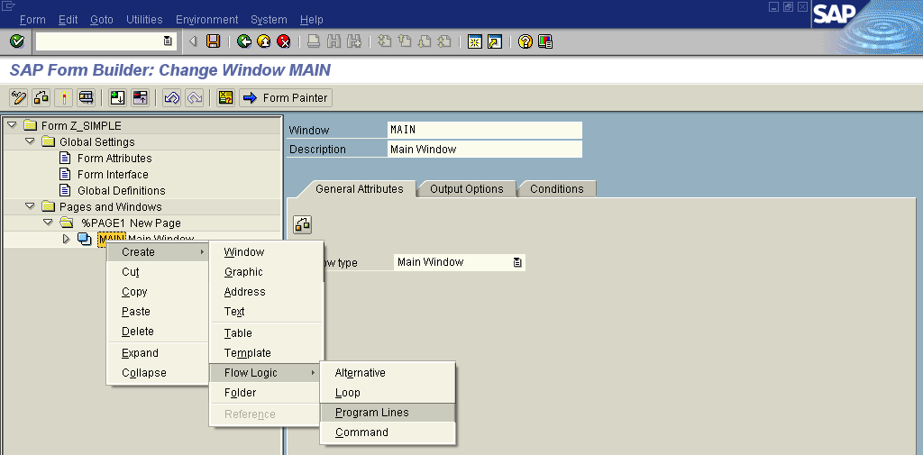
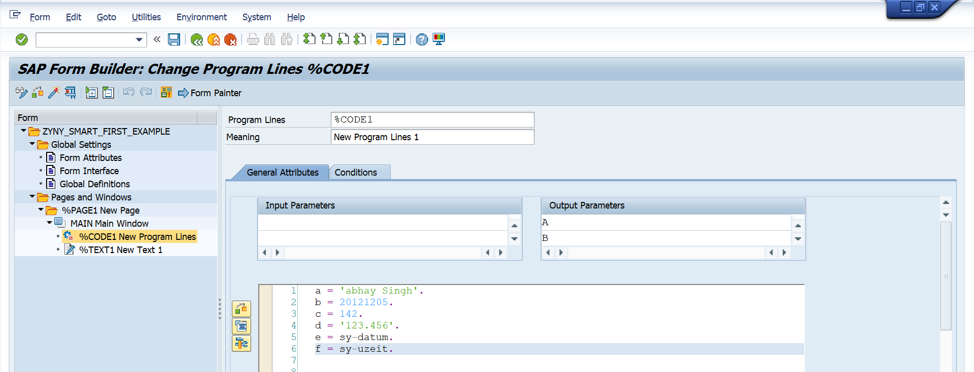

a = 'abhay Singh'.
b = 20121205.
c = 142.
d = '123.456'.
e = sy-datum.
f = sy-uzeit.

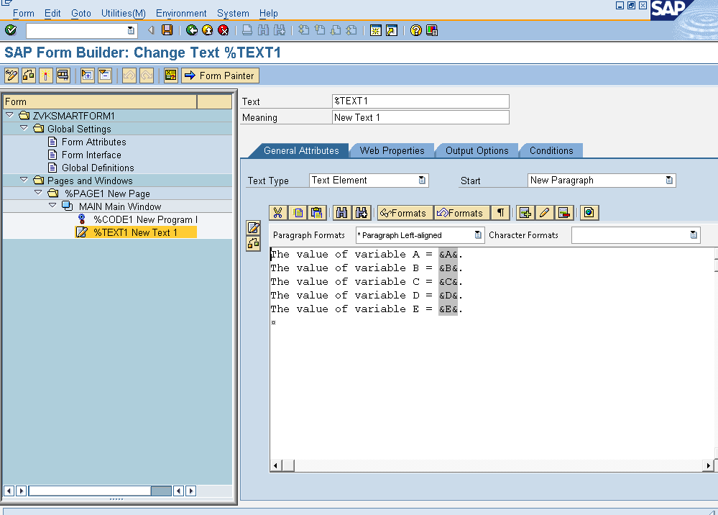

The value of variable A = &A&.
The value of variable B = &B&.
The value of variable C = &C&.
The value of variable D = &D&.
The value of variable E = &E&.
The value of variable F = &F&.

